|  |  |
| --- | --- |
| **Name** |  |
| **Reg. No** |  |
| **Marks / Grade** |  |

**EXPERIMENT # 09**

**To apply Series Capacitive Compensation in a Transmission lines**

**Objective:**

To learn the importance of Series Compensation by simulating a single phase and three phase medium length transmission line with different loads on MATLAB Simulink and PWS.

**Theory:**

Series compensation is the method of improving the system voltage by connecting a capacitor in series with the transmission line. In other words, in series compensation, reactive power is inserted in series with the transmission line for improving the impedance of the system. It improves the power transfer capability of the line. It is mostly used in extra and ultra-high voltage line.

Series compensation has several advantages like it increases transmission capacity, improve system stability, control voltage regulation and ensure proper load division among parallel feeders. These advantages are discussed below.

* [series-compensation-equation-1](https://circuitglobe.com/wp-content/uploads/2016/08/series-compensation-equation-1111-compressor.jpg)**Increase in Power Transfer Capability**The power transfer over a line is given by

where P1 – power transferred per phase (W)  
Vs – sending-end phase voltage (V)  
Vr – receiving-end phase voltage  
XL – series inductive reactance of the line  
δ – phase angle between Vs and Vr

If a capacitor having capacitance reactance Xc is connected in series with the line, the reactance of the line is reduced from XL to (XL– XC). The power transfer is given by

[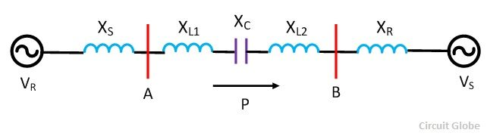](https://circuitglobe.com/wp-content/uploads/2016/08/series-compensation-compressor.jpg)

Figure 1: Three Phase Transmission lines with Series Capacitor

[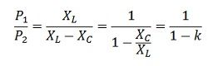](https://circuitglobe.com/wp-content/uploads/2016/08/series-compensation-equation-3-compressor.jpg)

[series-compensation-equation-2](https://circuitglobe.com/wp-content/uploads/2016/08/series-compensation-equation-2-compressor.jpg)

* **Improvement in System Stability –**For same power transfer and for the same value of sending and receiving end voltage, the phase angle δ in the case of the series impedance line is less that for the uncompensated line. The reduced value of δ gives higher stability.
* **Load Division among Parallel Line –**Series capacitors are used in transmission systems for improving the load division between parallel lines. When the new line with large power transfer capability is paralleled with an already existing line, then it is difficult to load the new line without overloading the old line. In such case the series compensation reduces the series reactance and proper load division among parallel circuit can be done easily. Load division increases the power transfer capability of the system and reduced losses.
* **Control of Voltage –**In series capacitor, there is an automatic change in Var (reactive power) with the change in load current. Thus, the drops in voltage levels due to sudden load variations are corrected instantly.

**Procedure:**

* Start MATLAB and go to start Simulink $>$ Simpower system $>$ Block Library.
* Open new file by clicking file new model or pressing ctrl+ n.
* Take Voltmeter and Ammeter from measurement section of Block Library.
* Take AC Voltage source from source section.
* Take RLC Load and branch, ground node, PI section line from element section.
* Also take Power GUI from block library simpower system in your file.
* Make connection as shown in figure.
* Calculate voltage regulation using formula.
* Now apply series capacitor at receiving end and see variation in voltage and current and their phase difference.
* Change value of capacitor and find trend variation in voltage, current and power factor.
* Repeat this system for different values of loads and capacitor values draw table and also draw graph for different values.

**Parameters of different components:**

**AC Voltage Source:**

Voltage Peak=_______________ , Frequency:

**Series RLC Branch:**

**R**=_______ , L=_______ ,C=__________

**Series RLC Load:**

R=________ , L=________ , C=_______

Three types of loads should be simulated for each T.L model.

* Pure resistive load
* Inductive load
* Capacitive Load

**Tasks:**

* Simulation is done in single phase system and draw tables and graphs.
* Simulation is done in three phase system and draw tables and graphs.
* Simulation is performed in PWS and draw tables and graphs.